First-principles Calculations of Stacking Stability of C₂N Bilayer Nanosheet

Klichchupong Dabsamut,¹ Sirichok Jungthawan,^{2,3} and Adisak Boonchun^{1,2*}

¹Department of Physics, Faculty of Science, Kasetsart University, Bangkok 10900, Thailand.
²School of Physics, Institute of Science, Suranaree University of Technology, Nakhon Ratchasima 30000, Thailand.
³Thailand Center of Excellence in Physics, Commission on the Higher Education, 328 Si Ayutthaya Road, Bangkok 10400, Thailand

* E-mail: adisak.bo@ku.th, fsciasb@ku.ac.th

In recent years, a 2D graphene-like sheet: monolayer C₂N was synthesized via a simple wetchemical reaction [1]. Here, we study the stability and electronic properties of bilayer C₂N. According to previous a study, a bilayer may exist in one of three highly symmetric stacking configurations, namely as AA, AB and AB’-stacking [2]. For the AA-stacking, the top layer is directly stacked on the bottom layer. Furthermore, AB- and AB’-stacking can be obtained by shifting the top layer of AA-stacking by a/3-b/3 along zigzag direction and by a/2 along armchair direction, respectively, where a and b are translation vectors of the unit cell. By using first-principles calculations, we calculated the stability of AA, AB and AB’-stacking C₂N and their electronic band structure. In previous result, the most favourable structure is AB-stacking. In present work, we furthermore examined the energy landscape and translation sliding barriers between stacking layers. From energy profiles, we interestingly found that the most stable positions are shifted from the high symmetry AB-stacking. In electronic band structure details, band characteristic can be modified according to the shift.
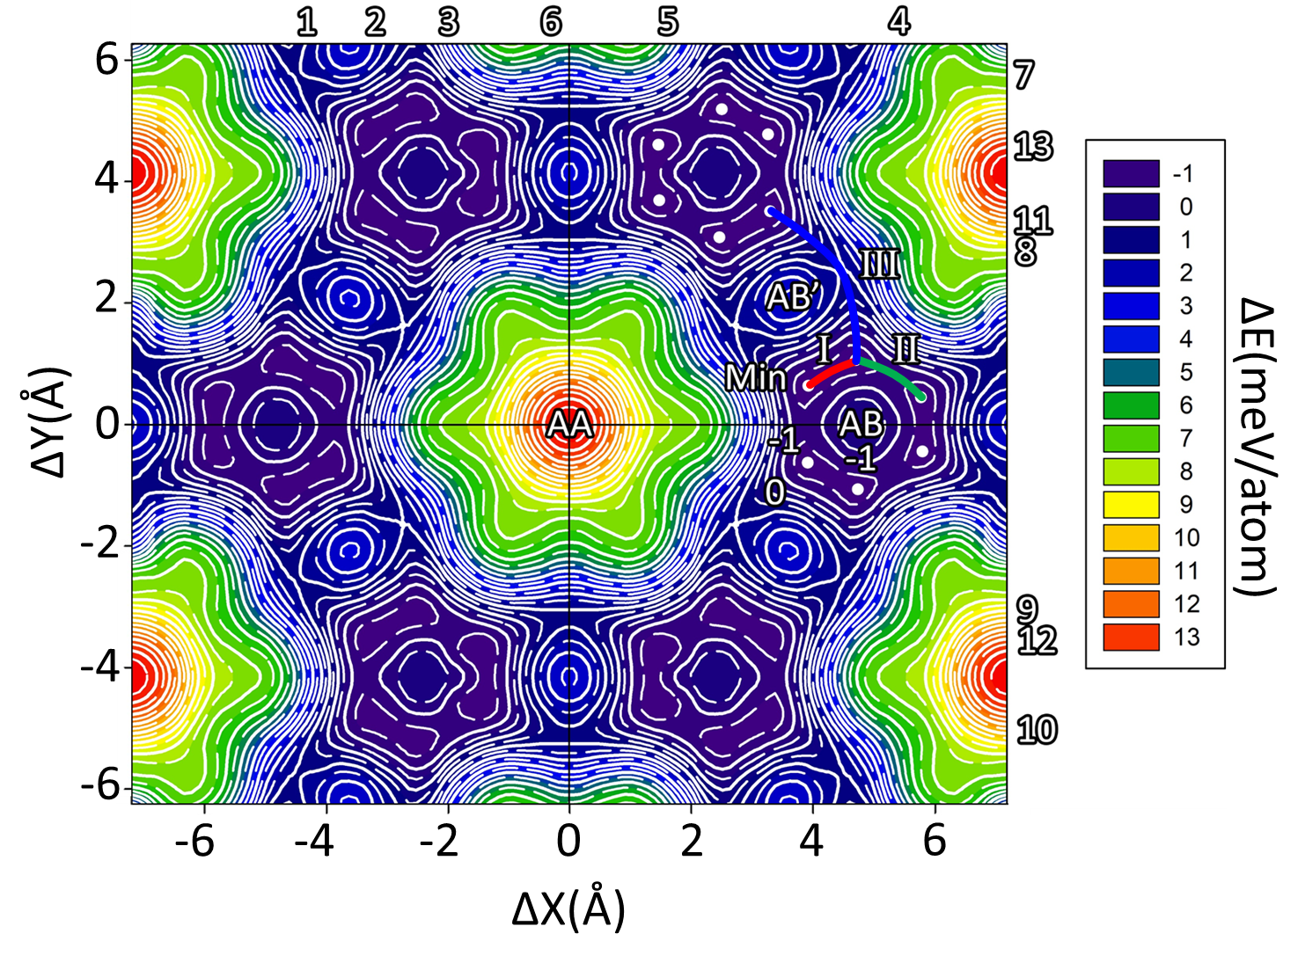
Fig 1. 2D-energy profile surface of bilayer C₂N depending on the inter-layer relative slide distance (ΔX, ΔY).
- J. Mahmood, E. K. Lee, M. Jung, D. Shin, I.-Y. Jeon, S.-M. Jung, H.-J. Choi, J.-M. Seo, S.-Y. Bae and S.-D. Sohn, Nature communications 6, 6486 (2015).
- R. Zhang, B. Li and J. Yang, Nanoscale 7 (33), 14062-14070 (2015).

