DFT-based engineering of Dirac surface states in topological insulator multilayers

Takao Kosaka,* Kunihiko Yamauchi, and Tamio Oguchi

Institute of Scientific and Industrial Research, Osaka University, 8-1 Mihogaoka, Ibaraki, Osaka 567-0047, Japan

* E-mail: t.kosaka@cmp.sanken.osaka-u.ac.jp

Topological insulators exhibit the non-trivial quantum states which can be characterized by the insulating bulk states and spin-polarized metallic surface states, such as surface states with Dirac cone, being expected for spintronics device applications. The highly insulating bulk state and the tunable Dirac cone are required for the future device applications. Nevertheless, many of topological insulators have been found to be metallic due to the existence of impurities and disorder. It has been reported that the ternary tetradymite topological insulator materials such as Bi₂Te₂Se [1], which forms the ordered Te-Bi-Se-Bi-Te quintuple layers, and Bi_{2-x}Sb_{x}Te_{3-y}Se_{y} solid solution [2,3] have highly bulk insulating states, because the defect formation is suppressed in these materials. In additoin to such defect control, one can obtain spin-polarized Dirac carries with the Dirac point in the band gap. In this study, we control the Dirac surface states by engineering topological multilayer structures using first-principles calculations based on density functional theory. The computational results show that the Dirac point can be modulated in energy by differentiating work functions between the surface layers and the inner layers to realize the desired band strcuture as shown in Fig. 1.
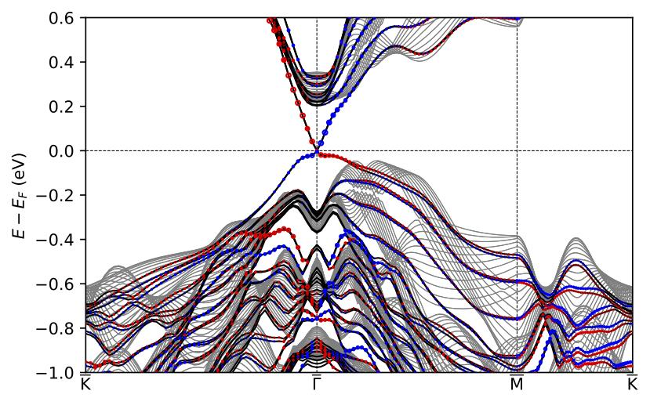
Fig. 1: Band sturcture of topological insulator multilayers: bulk band in black and surface states in red and blue.

[1] Z. Ren, A. A. Taskin, S. Sasaki, K. Segawa, and Y. Ando, Phys. Rev. B 85, 155301 (2012).
[2] Z. Ren, A. A. Taskin, S. Sasaki, K. Segawa, and Y. Ando, Phys. Rev. B 82, 241306(R) (2010).
[3] T. Arakane, T. Sato, S. Souma, K. Kosaka, K. Nakayama, M. Komatsu, T. Takahashi, Z. Ren, K. Segawa, and Y. Ando, Nat. Commun. 3, 636 (2012).

