Energetics and optical properties of carbon impurities

in rutile TiO₂

Supparat Charoenphon,¹ Adisak Boonchun^{1,2}, and Pakpoom Reunchan,^{1,2*}

¹Department of Physics, Faculty of Science, Kasetsart University,
Bangkok 10900, Thailand
²Thailand Center of Excellence in physics (ThEP Center), Commission on Higher Education, Bangkok 10400, Thailand

* E-mail: pakpoom.r@ku.ac.th

Titanium dioxide (TiO₂) is one of the most promising materials for many applications such as solar-cell system and photocatalysis. Non-metal doping of TiO₂ is widely used to improve the photoconversion of the material by shifting the absorption edge from UV to visible-light region [1, 2]. Here, we employ hybrid density-functional calculations to investigate the energetics and electronic structures of carbon (C) impurities in rutile TiO₂. The predominant configurations of C impurities under the O-poor and O-rich growth conditions are identified through the calculated formation energies. Under the O-poor condition, we find the substitutional C occupying oxygen site (C_{O}), as shown in FIG. 1, is energetically favorable for Fermi-level values near the conduction band minimum (n-type TiO₂) where it acts as double acceptor. On the other hand, when Fermi-level positions decrease toward the valence band, C atoms favor to form the C_{i}-V_{O} complex, as shown in FIG. 2, acting as sextuple donor. Under the O-rich condition, the C_{i}-V_{Ti} complex is found to be energetically favorable in n-type TiO₂, and is exclusively stable in charge neutral. Our calculations based on the configuration coordinated diagram suggest that C_{O} is an origin of visible light absorbtion in n-type rutile TiO₂ fabricated under oxygen deflicient growth condition.
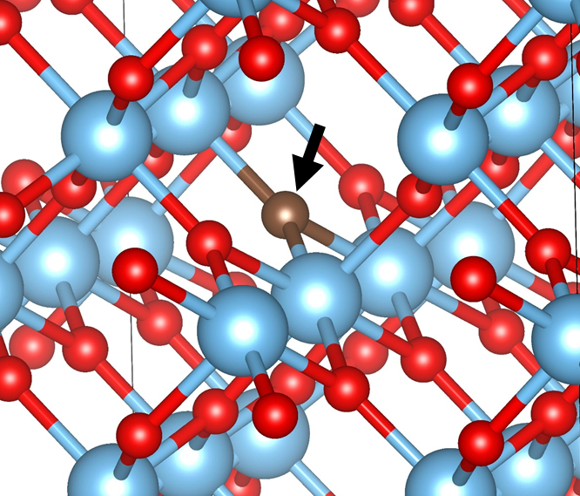
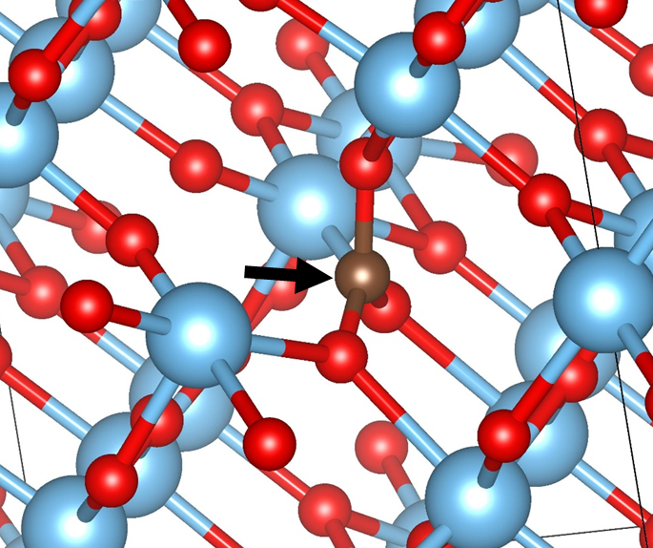

FIG. 2. (Color online) Local atomic configuration of the C_{i}-V_{Ti} complex. The interstitial C is indicated by the arrow.
FIG. 1. (Color online) Local atomic configuration of the substitutional C occupying O site (C_{O}) in rutile TiO₂. The substitutional C is indicated by the arrow [Ti: blue, O: red, C: dark brown].

[1] Asahi, R.; Morikawa, T.; Ohwaki, T.; Aoki, K.; Taga, Y. Science 2001, 293, 269.
[2] Khan, S. U. M.; Al-Shahry, M.; Ingler, W. B., Jr. Science 2002, 297, 2243.

