The effect of strain on the phonon thermal transport properties of
the two-dimensional 2H-MoTe₂

Aamir Shafique and Young-Han Shin∗

Department of Physics, University of Ulsan, Ulsan 44610, Republic of Korea

∗E-mail : hoponpop@ulsan.ac.kr

The strain is a handy and useful tool to enhance the performance of the semiconducting devices. It can tune electronic, optical, and thermoelectric properties. However, the effect of tensile strain on the phonon thermal transport of two-dimensional materials is unpredictable because the flexural acoustic (ZA) mode becomes harder and transverse acoustic (TA) and longitudinal acoustic (LA) modes become softened. Here, we study strain-dependent lattice thermal conductivity and other phonon properties such as phonon group velocity, phonon anharmonicity, phonon lifetime of the two-dimensional 2H-MoTe₂ using the Boltzmann transport theory for phonon coupled with the first principles calculations. We find that the lattice thermal conductivity is reduced approximately 2.5 times at 8% tensile strain for the two-dimensional 2H-MoTe₂ contrary to graphene, germanene, silicene, germanene, and Penta-SiC₂. The reduction in lattice thermal conductivity attributes to the reduction in the phonon group velocity, the phonon heat capacity, and the phonon scattering time. We have also evaluated the contribution of each mode to the lattice thermal conductivity. The ZA mode contribution decreases while the TA/LA modes contributions increase under tensile strain. These results highlight that tensile strain is a key parameter to tune the lattice thermal conductivity and other phonon thermal transport properties of the two-dimensional 2H-MoTe₂.

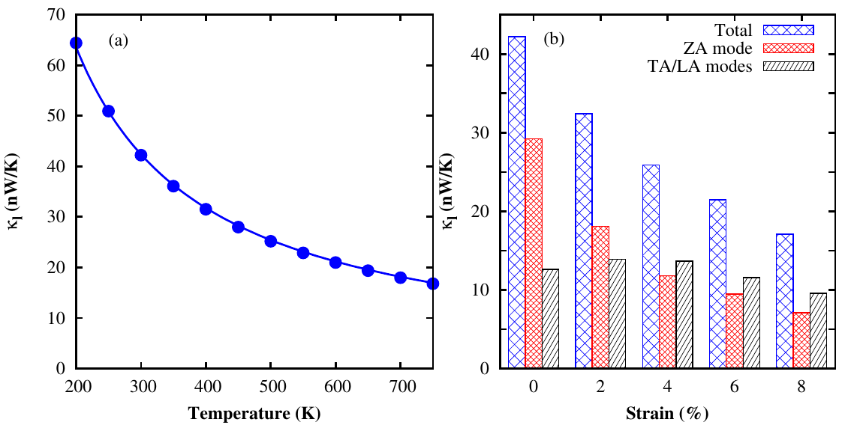

Figure 1: (a) Lattice thermal conductivity of monolayer 2H-MoTe₂ as a function of temperature at zero strain, and (b) total lattice thermal conductivity, showing the contribution of the ZA and TA/LA modes to the lattice thermal conductivity at 300 K as a function of tensile strain at 300K.

