Tunable Thermoelectric Effects of Bilayer Graphene by Vertical Electric Field

Hikaru Horii¹, Kenji Sasaoka², Takahiro Yamamoto^{1,2,*} and Hidetoshi Fukuyama³

¹Fac. of Engineering, Tokyo Univ. of Science, Katsushika, Tokyo 125-8585, Japan
²WFS-T, RIST, Tokyo Univ. of Science, Katsushika, Tokyo 125-8585, Japan
³Tokyo University of Science, Shinjuku, Tokyo 162-8601, Japan

*E-mail: takahiro@rs.tus.ac.jp

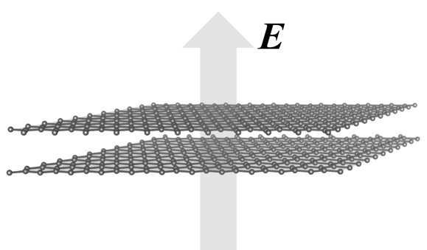
Thermoelectric (TE) generation is a potential key technology for recovering energy from waste heat. Among the various potential candidates for TE materials, nanocarbon materials have attracted attention as flexible and high-performance TE materials. Most recently, Yamamoto and Fukuyama reported that the semiconducting carbon nanotubes (CNTs) exhibit high TE performance when the chemical potential μ locates near a band edge with sharp density of states (DOS) originating from its one dimensionality [1,2]. On the other hand, the graphene, which is a two-dimensional honeycomb lattice consisting of carbon atoms, cannot be expected to be high-TE performance because it has no band gap at the charge neutral point.
Fig. 1: Bilayer graphene under vertical electric field
In this study, we focus on the bilayer graphene (BLG) since the bandgap can be opened by applying the electric field perpendicular to the BLG, as shown in Fig. 1 [3]. We have calculated the Seebeck coefficient S and the power factor PF of the BLG in the presence of vertical electric field $E_{⊥}$ using the Kubo’s linear response theory combined with thermal Green’s function method which was recently developed [1,2]. We adopt the constant-τ approximation for self-energy due to carrier scattering [2].
We found that the values of S and PF can be controlled by changing the magnitude of $E_{⊥}$. For example, we obtained S ~ 200 μV/K and PF ~ 40 mW/mK² when μ lies close to a band edge and the vertical electric field is $E_{⊥}$ = 4.8 MV/cm. This is because the DOS of BLG under $E_{⊥}$ has a sharp peak near the band edge, which is similar to carbon nanotubes. On the other hand, in the high-energy regimes where μ is much larger than the band gap, S is inversely proportional to the chemical potential, i.e., S ∝ μ⁻¹. The μ⁻¹ behavior of BLG is similar to the case of CNTs. In contrast to S, the thermoelectric conductivity L₁₂, which is defined as the electric current density in response to the temperature gradient, shows the different μ dependence between the two-dimensional BLG and one-dimensional CNTs.

[1] T. Yamamoto and H. Fukuyama, J. Phys. Soc. Jpn. 82, 024707 (2018).
[2] T. Yamamoto and H. Fukuyama, J. Phys. Soc. Jpn. (in press).
[3] T. Ohta et al. , Science 313, 951 (2006).

