Theoretical insight into methane oxidation to methanol on single Fe-embeded nitrogen-doped graphene

Thantip Roongcharoen,¹ Nawee Kungwan, ^{1,*}, Supawadee Namuangruk^{2,*}

¹ Department of Chemistry, Faculty of Science, Chiang Mai University, Chiang Mai, Thailand
²National Nanotechnology Center (NANOTEC), 111 Thailand Science Park, Patumthani 12120, Thailand
* E-mail: naweekung@gmail.com, supawadee@nanotec.or.th

Methane, a major component in natural gas and biogas, is an important chemical feedstock for synthesis of methanol as more valuable compound. Methanol is renewable source in many industries. To convert methane to methanol, there are several technologies such as supercritical water process, plasma technology, biological process, photo-catalysts, and catalytic process. Among them, catalytic process is popular approach because the methane goes through oxidation processes under mild condition with high yield. Different types of catalysts methane oxidation such as metal-exchanged zeolites, metal catalyst, and carbon-based catalyst have been widely investigated. Modified graphene as one of carbon-based materials has become attractive catalysts because its properties are suitable for example, high specific surface volume ratio, low energy consumption, low cost, and non-toxic materials. Among the modified graphene materials, Fe embedded on nitrogen-doped graphene (Fe-N_{x}G; x=1,2,3) is one of the most interesting catalysts because it has specific active sites and can modulate the Femi-level leading to enhancement of catalytic activity. These materials (Fe-N_{x}G) exhibit high chemical activity in various fields for example, Fe-N3G, and Fe-N4G for oxygen reduction reaction (ORR). However, the reactivity of Fe-N_{x}G catalysts in methane oxidation are not well understood. Therefore, in this work, the methane oxidation mechanism using Fe-N_{x}G catalysts will be systematically investigated. Finally, the reactivity of Fe-N_{x}G will be compared with other catalysts.
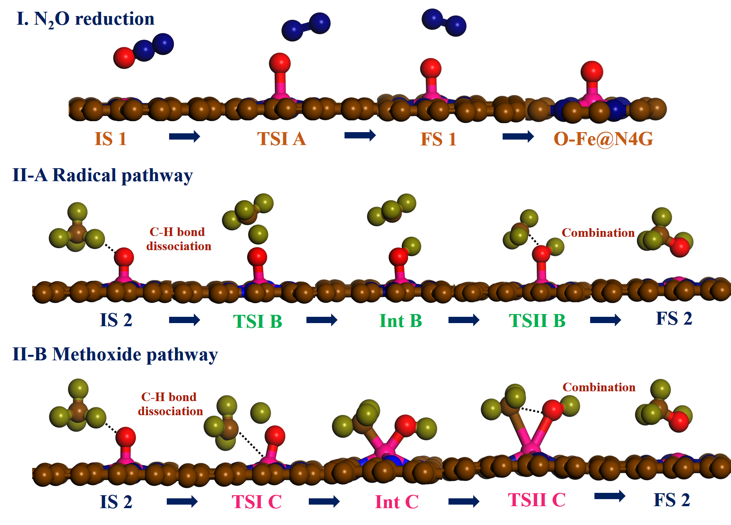
Fig.1 Proposed mechanism of methane oxidation present of N₂O reduction on Fe-embedded on functionalized graphene (Fe-N_{x}G).
[1] Z. Zakaria, S.K. Kamarudin, Renewable and Sustainable Energy Reviews, 65
(2015) 250-261.
[2] L.Yung-Chang, Nano Lett. 15 (2015),7408−7413.
[3] Q. Thalia, C. Pabitra, Molecular Catalysis 431 (2017) 9-14.

