Performance information of first-principles codes in K computer

Kanako Yoshizawa

Research Organization for Information Science and Technology, Kobe 650-0047, Japan

* E-mail: yoshizawa@rist.or.jp

HPCI (High Performance Computing Infrastructure) System including "K computer" [1] provides high performance computing services for scientists and researchers around the world. User selection and support is conducted by RIST (Research Organization for Information Science and Technology) in HPCI. As part of the user support, RIST has installed application software most commonly used in HPCI research projects. The installation status and usage information of each software are introduced [2].
I have measured the performance of first-principles codes in K computer as port of usage information. The performance information of Quantum ESPRESSO (PWscf) [3] for Titanium dioxide (TiO₂) is shown in Figure. I show not only the performance information but also efficient execution methods (e.g. specifying the runtime options) in K computer.
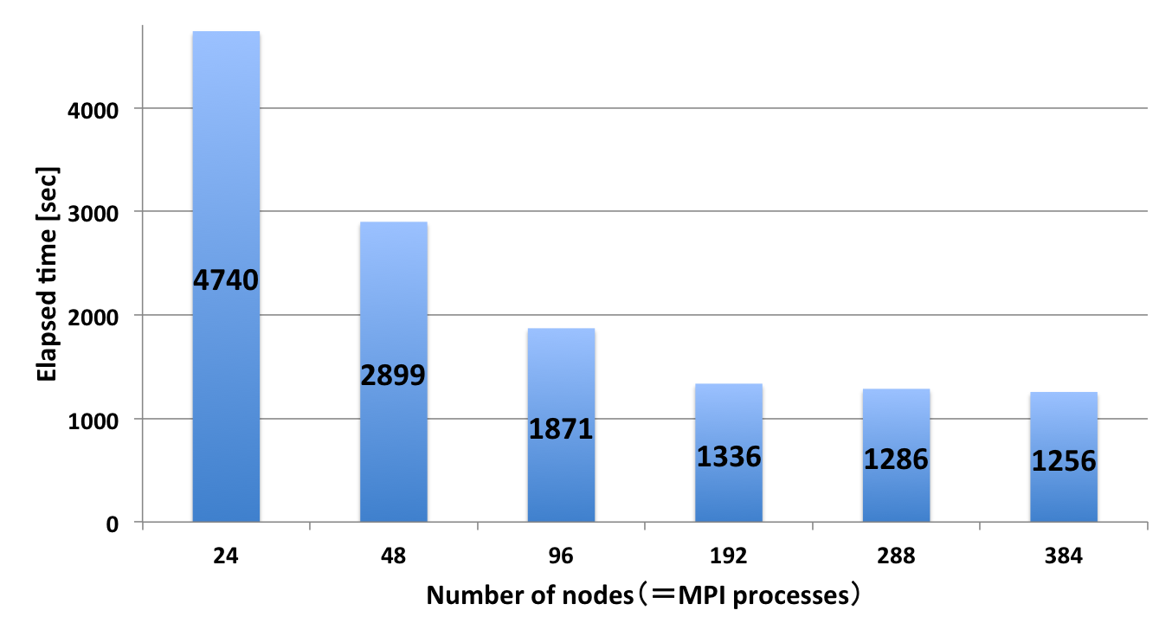
Figure: The performance information of PWscf v6.1 for addition of a hydrogen in rutile TiO₂ (217 atoms per unit cell). The hybrid parallel job running multiple processes and 8 threads.

- http://www.hpci-office.jp/folders/english.
- http://www.hpci-office.jp/pages/e_appli_software.
- http://www.quantum-espresso.org.

