Path Integral Molecular Dynamics Simulations for Muoniated Thioformaldehyde Radicals

Narissa Kanlayakan¹, Yuki Oba², Nawee Kungwan^{1,*} and Masanori Tachikawa^{2,*}

¹Department of Chemistry, Faculty of Science, Chiang Mai University, Chiang Mai, Thailand
²Quantum Chemistry Division, Graduate School of NanoBioscience, Yokohama City Uniersity, Yokohama, Japan

* E-mail: naweekung@gmail.com and tachi@yokohama-cu.ac.jp

A considerable amount of knowledge for muonium (Mu; complex of a positive muon (μ⁺) atom and an electron) chemistry has been accumulated for over 30 years [1]. A muon has a smaller mass and larger magnetic moment than those of proton. Because of these unique features, Mu atom is used as the muon spin resonance/
rotation/relaxation (µSR), where hyperfine coupling constant (HFCC) is a good index for the magnetic interaction between electron and muon spins. In this study, we investigated the structures and “reduced” HFCC values for muoniated and hydrogenated thioformaldehyde radicals, a Mu or H atom is added to carbon atom (C-adduct) or sulfur atom (S-adduct) of the thioformaldehyde compound (H₂C=S) using the on-the-fly ab initio path integral molecular dynamics (PIMD) method [2, 3], which can include both nuclear quantum and thermal effects. The single point energy of C adduct structure with CCSD/aug-cc-pVDZ (optimized with MP2/6-311++G(d,p)) level is 13.48 lower than that of S-adduct structure, corresponding the previous study [4]. The HFCC values from a simple geometry optimization calculation of C adduct and S adduct are 22.42 and -7.39 MHz, respectively, at the BHandHLYP/6-31+G(d,p) level. In case of C-adduct, the reduce HFCC values of the muoniated thioformaldehyde radical by our PIMD simulation is slightly larger than that of hydrogenated radical with the same calculation level. We found that the local molecular structures affect the HFCC values, particularly, the Mu⸺C bondlength in the muoniated thioformaldehyde radical is lengthen due to the large nuclear quantum effect of moun.
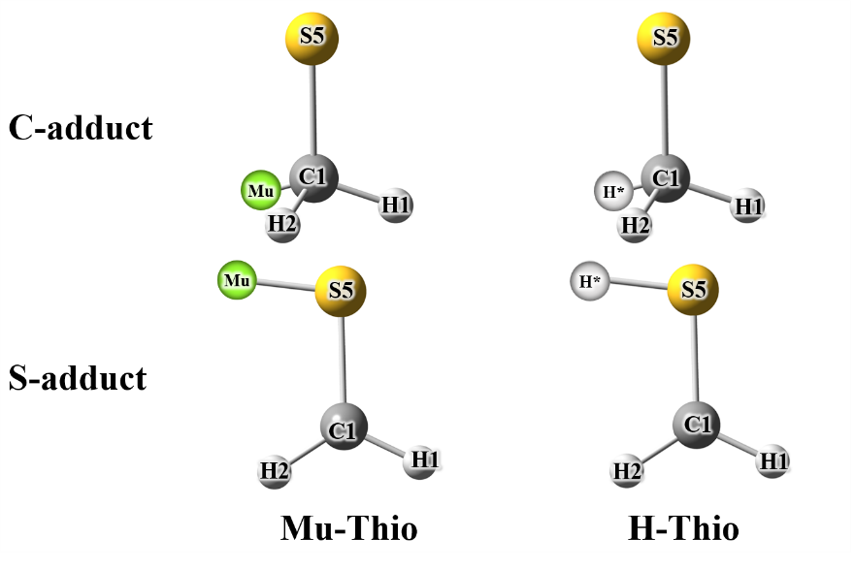
Figure 1. The optimized structure of muoniated and hydrogenated thioformaldehyde radicals (Mu-Thio and H-Thio).

- P. W. Percival, Radiochemica Acta 26, 1 (1979).
- K. Yamada, Y. Kawashima, and M. Tachikawa, J. Chem. Theory Comput. 10, 2005 (2014).
- Y. Oba, T. Kawatsu, and M. Tachikawa, J. Chem. Phys. 145, 064301 (2016).
- T. Kobayashi, K. Seki, T. Tanaka, and T. Takayanagi, Comput. Theor. Chem. 963, 2-3 (2011).

