Electronic and Photophysical Properties of Derivatives of 2-Phenylbenzothiazole and 2-(2´-Hydroxyphenyl) benzothiazole: Effect of Intramolecular Hydrogen Bonding

Rusrina Salaeh, Chattarika Sukpattanacharoen, Poowadon Chai-in
and Nawee Kungwan*

Department of Chemistry and Center of Excellence for Innovation in Chemistry (PERCH-CIC), Faculty of Science, Chiang Mai University, Chiang Mai 50200, Thailand.

* E-mail: naweekung@gmail.com

Photophysical properties of 2-phenylbenzothiazole (PBT) denoted as a No-PT type compound and 2-(2´-hydroxyphenyl)benzothiazole (HBT) denoted as a PT type compound as well as their derivatives have been investigated using six different DFT and TD-DFT methods. The B3LYP exchange-correlation functional with 20% HF exchange is found to be the most suitable method for reproducing experimentally photophysical data. Overall, the simulated absorption and emission spectra of all derivatives are red-shifted compared with their parent compounds, PBT and HBT, except emission spectrum of TPy-1 is blue-shifted. Especially, TPy-3 and HTP-2, of which the carbon atoms at 4,7-positions of the benzothiazole core are replaced by nitrogen atoms and hydrogen atoms in the 2,6-positions are substituted by dimethylamino phenyl groups, show more red-shifted absorption spectra than other compounds caused by lone pair electron of nitrogen atoms and electron donating group that has the effect on the π-conjugated system. In addition, TPy-4 and HTP-3 also have the similar effect on π-conjugated system. As expected, the calculated Stokes shifts of the PT type compounds are larger than that of the No-PT type compounds, because of the tautomer formation through the excited state intramolecular proton transfer (ESIPT) process. The potential energy curves (PECs) scanned along the proton transfer (PT) coordinate of the PT type compounds reveal that the ESIPT process is more likely to proceed in the S₁ state. The ESIPT process in HBT, HTP and HTP-1 occurs with a small barrier or barrierless, whereas that in HTP-2 and HTP-3 involves a higher barrier. The PT barriers were found to be in the order of HTP ~ HBT > HTP-1 > HTP-2 > HTP-3. The knowledge accumulated through these studies is expected to be useful for the rational design of fluorescent molecular probes.
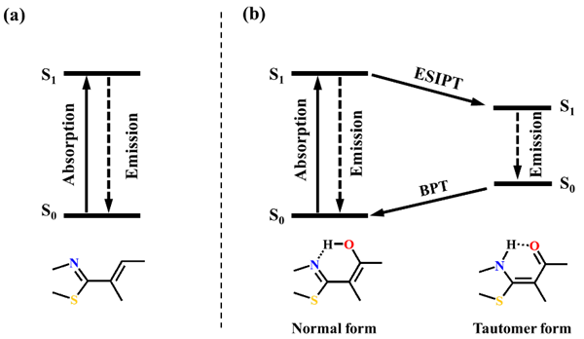
Figure 1. Photocycle of (a) molecules without proton transfer (No-PT type) and (b) molecules with intramolecular proton transfer (PT type)
REFERENCES
[1] Kwon, J. E., Park, S. Y., Adv. Mater. 2011, 23, 3615-3642.
[2] Nakagawa, T., Yamaji, M., Maki, S., Niwa, H., Hirano, T., Photochem. Photobiol. Sci.
2014, 13, 1765-1772.
[3] Suzuki, Y., Yamaji, M., Maki, S., Hirano, T., J. Photochem. Photobiol. A: Chemistry 2016,
314, 93-95.

