Efficient O(N) divide-conquer method

with localized natural orbitals

Taisuke Ozaki, ^{1,*} Masahiro Fukuda,¹ and Gengping Jiang²

¹Institute for Solid State Physics, The University of Tokyo, Kashiwa, Japan.
²College of Science, Wuhan University of Science and Technology, Wuhan, 430081, China.

* E-mail: t-ozaki@issp.u-tokyo.ac.jp

An efficient O(N) divide-conquer (DC) method based on localized natural orbitals (LNOs) is presented for large-scale density functional theories (DFT) calculations of gapped and metallic systems [1]. The LNOs are non-iteratively calculated by a low-rank approximation via a local eigendecomposition of a projection operator for the occupied space. Introducing LNOs to represent the long range region of a truncated cluster reduces the computational cost of the DC method while keeping computational accuracy. The novel O(N) method has been implementd into OpenMX DFT code which is based on optimized localized numerical orbitals and norm-conserving pseudopotentials [2], and a series of benchmark calculations and high parallel efficiency in a multilevel parallelization clearly demonstrate that the O(N) method enables us to perform large-scale simulations for a wide variety of materials including metals with sufficient accuracy in accordance with development of massively parallel computers.

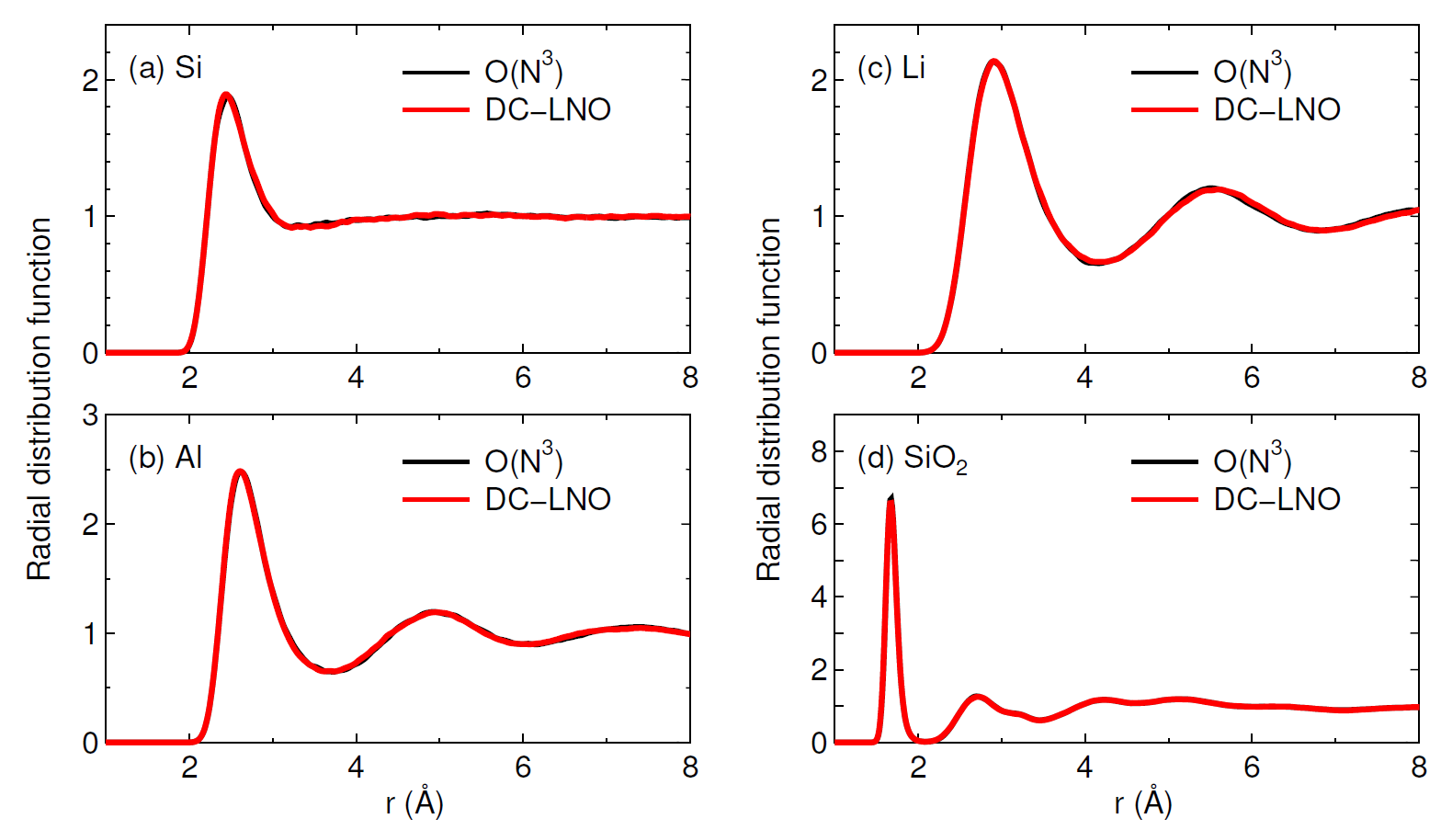
Fig. Radial distribution functions of liquids for (a) Si at 3500 K, (b) Al at 2500 K, (c) Li at 800 K, and (d) SiO2 at 3000 K calculated by the O(N³) and DC-LNO methods.

[1] T. Ozaki, M. Fukuda, and G. Jiang, arXiv:1809.05637.
[2] http://www.openmx-square.org/

