**First-Principles Study on Electron Transport Properties of Halogenated Graphene**

Yoshiyuki Egami1 and Masahiro Kudo2

*1* *Faculty of Engineering, Hokkaido University, Sapporo, Hokkaido, Japan*

*2School of Engineering, Hokkaido University, Sapporo, Hokkaido, Japan*

* E-mail: y_egami eng.hokudai.ac.jp

Recently, an electronic device constructed from a graphene has been investigated extensively and has been expected to be a candidate for replacing silicon-based devices owing to several unique properties of the graphene (rapid electron transfer, good thermal conductivity, and splendid flexibility). A lot of experimental and theoretical studies on physical functionalizations and chemical modifications of graphene for tuning these properties have been performed. A chemical adsorption of atoms and molecules on the graphene surface is one of important modifications. In particular, a halogen adatom X (X=F, Cl, Br, and I) can change the atomic and electronic structures of the grapehen drastically, where the formation of C-X covalent bonds is accompanied by sp2 to sp3 structural transition of C-C bonds (Fig. 1).

In this work, the electron transport properties of the halogenated graphene are investigated. Here, we performed the molecular dynamics calculations to determine a fully-relaxed atomic geometry of halogenated graphene using the RSPACE code[1], which is based on the real-space finite difference approach within a framework of the density functional theory. Moreover, we curried out the electron transport simulations[2] to estimate the dependence of the electric conductivity and the spatial path of current flow on the coordinates and species of adsorbed halogen atoms. The details of this work are presented at the workshop.

Fig. 1: Schematic view of a halogenated graphene. There are six halogen atoms (green spheres) and each atom form a covalent bond with a carbon atom (grey spheres).

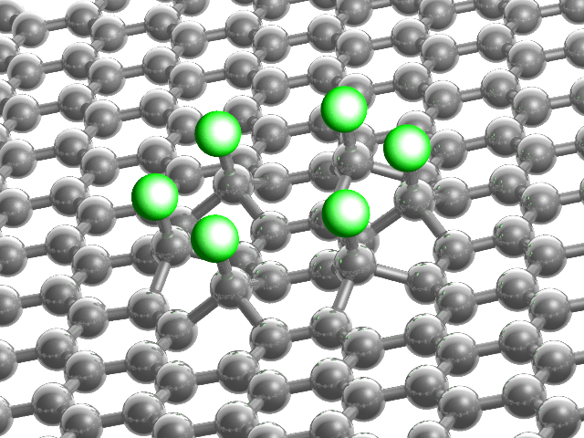

1. K. Hirose, T. Ono and Y. Fujimoto, and S. Tsukamoto, *First-Principles Calculations in Real-Space Formalism*, (Imperial College Press, London, 2005).
2. Y. Egami, K. Hirose, T. Ono, Phys. Rev. E **82**, 056706 (2010); Y. Egami, S. Iwase, S. Tsukamoto, T. Ono, K. Hirose, Phys. Rev. E **92**, 033301 (2015).