First-principles study of Electric-field induced Z₂ topological phase transition in strained one-bilayer Bi(111)

Hikaru Sawahata,^{1,*} Naoya Yamaguchi¹ and Fumiyuki Ishii^{2,†}

¹Graduate School of Natural Science and Technology of Science and Technology, Kanazawa University, 920-1192, Japan
²Nanomaterials Research Institute, Kanazawa University, 920-1192, Japan
* E-mail: sawahata@cphys.s.kanazawa-u.ac.jp
† E-mail: ishii@cphys.s.kanazawa-u.ac.jp

Electric-field induced Z₂ topological phase transition is important for applications of a Z₂ topological insulator. If we are able to switch from Z₂ topological insulating phase to trivial insulating phase or vice versa by the electric field, novel devices using edge spin currents could be realized. We predicted that one-bilayer Bi(111) shows electric-field induced Z₂ topological phase transition by first-principles calculations[1]. The bandgap is closed at the electric field E = 2.1 V/Å and one-bilayer Bi(111) shows Z₂ topological phase transition from Z₂ topological insulating phase (E < 2.1 V/Å) to trivial insulating phase (E > 2.1 V/Å). In order to realize device applications, the critical electric field should be reduced by tuning the bandgap.
In this study, we performed fully relativistic density functional calculations of the bandgap and Z₂ topological invariant in strained one-bilayer Bi(111) shown in Fig. (a). In order to compute Z₂ topological invariant using OpenMX code [2], we have implemented Fukui-Hatsugai method[3] which can be applied to the system without space inversion symmetry. Figure (b) shows the Z₂ topological phase diagram of one-bilayer Bi(111) in the space of the electric field and strain with the 3D plot of the band structure at the strain 0.5 %. The bandgap of one-bilayer Bi(111) is closed at the strain 0.5 %, and quadratic band touching[4] appears at Γ point. Near the strain 0.5 %, the critical electric field is reduced to E < 1.0 V/Å. In the poster session, we will present our detailed calculated results and how to implement Fukui-Hatsugai method in OpenMX code.
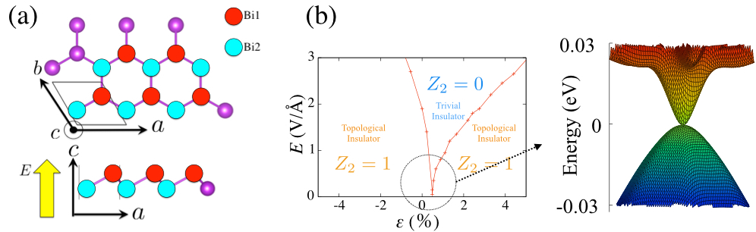Figure: (a) The structure of one-bilayer Bi(111) (b) The Z₂ topological phase diagram with the 3D plot of quadratic band touching at the strain 0.5 %
[1] H. Sawahata, N. Yamaguchi, H. Kotaka, and F. Ishii, Jpn. J. Appl. Phys. 57, 030309 (2018).
[2] T. Ozaki et al., http://www.openmx-square.org/.
[3] T. Fukui and Y. Hatsugai, J. Phys. Soc. Jpn. 76, 053702 (2007).
[4] K. Sun, H. Yao, E. Fradkin, and S. Kivelson, Phys. Rev. Lett. 103, 046811 (2009).

