Heteroatom effect on electronic and photophysical properties of

3-hydroxyquinolin-4(H)-one and its analogues enhancing

in the excited-state intramolecular proton transfer processes:

A TD-DFT study on substitution effect

Chattarika Sukpattanacharoen¹, Rusrina Salaeh¹, Nawee Kungwan^{1,2,*}
¹Department of Chemistry, Faculty of Science, Chiang Mai University, Chiang Mai 50200, Thailand
²Center of Excellence in Materials Science and Technology, Chiang Mai University, Chiang Mai 50200, Thailand

* E-mail: naweekung@gmail.com

The effect of hetero oxygen and nitrogen substituted of 3HX derivatives (3HQ, 3HF, 3HTF, and 3HSO where X=NH, O, S, and SO₂ respectively) on the electronic, photophysical properties, and excited-state intramolecular proton transfer (ESIPT) was investigated using density functional theory (DFT) and time-dependent DFT (TD-DFT). Geometries and absorption spectra as well as emission spectra of 3HX derivatives were carried out by using DFT and TD-DFT at the B3LYP/TZVP level. The important parameters for bond distances involving the intramolecular H-bond reveal that H-bonds of 3HX derivatives in excited-state are stronger than those in the ground state, supported by the red-shift of O–H vibrational modes in the excited-state. The heteroatom substitution of 3HX causes the red-shift emission spectra, implying that the lone pair of electron in the substituted heteroatom has the effect on the intramolecular charge transfer. In addition, results of frontier molecular orbitals show that vertical S₀→S₁ transition of these molecules corresponds essentially to the excitation from HOMO (π) to LUMO (π*). The potential energy curves (PECs) of intramolecular proton transfer (IntraPT) process of all derivatives were used to investigate the occurrence of ESIPT. The hetero sulfur on X positions of 3HX derivatives could easily facilitate the ESIPT process because sulfur makes O₁–H₁ bond of 3HTF weaker than those of other derivatives confirmed by its more red-shifted vibrational modes in the excited-state compared with other heteroatom substitutions, resulting in lower ESIntraPT barrier. The obtained information of the electronic structure, the photophysical property and the chance of ESIPT of heteroatom substituted 3HX molecules are useful for the molecular design of fluorescent molecular probes.
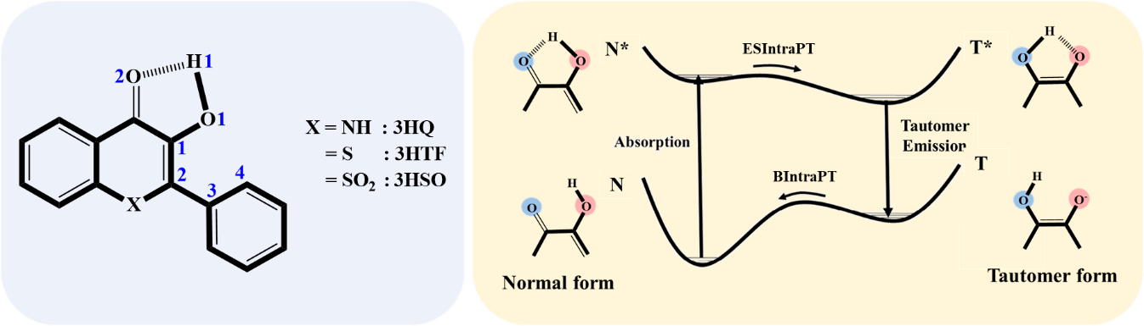

Figure. Schematic of 3HQ, 3HF, 3HTF, and 3HSO and Schematic diagram of the general ESIPT process, a proton donor and proton acceptor are circled with red and blue, respectively.

Keywords: Excited state proton transfer (ESPT), 3-Hydroxyquinolin-4(H)-one, Heteroatom effect, B3LYP

REFERENCES
[1] Meng, F. Y., Chen, Y. A., Chen, C. L., & Chou, P. T., ChemPhotoChem., (2018).
[2] Salaeh, R., Prommin, C., Chansen, W., Kerdpol, K., Daengngern, R., Kungwan, N., Journal of Molecular Liquids., 252, 428-438 (2018).
[3] Zamotaiev, O. M., Shvadchak, V., Sych, T. P., Melnychuk, N. A., Yushchenko, D., Mely, Y., Pivovarenko, V. G., Methods Appl. Fluoresce., 4, 3, 034004 (2016).

