Water droplet affects charge distribution of carbon nanotube

Koki Harada¹, Kenji Sasaoka², Takahiro Yamamoto^{1,2}

¹ Department of Electrical Engineering, Tokyo University of Science, Tokyo 125-8585, Japan
² Water Frontier Science & Technology Research Center, RIST, Tokyo University of Science, Tokyo 125-8585, Japan

* E-mail: 4317656@ed.tus.ac.jp

Water can be found on varius material surfaces in nanometer scale layer in ambient air. This water layer often affect material surface propertes such as friction and adhension force, chemical reactivity or electrical conductivity onsurface.

With it’s large surface area, carbon nanotube (CNT) is good material to resurch surface. CNT films are highly responsive, so they expected as promising materials for high sensitivity gas sensors. When CNT film gas sensors are used for NO₂ or formaldehyde, the response to water vapor is obstacle. Therefore, understanding the mechanism and magnitude of influence of water vapor on CNT films is needed to develop high accuracy CNT sensors. Although it is believed that the conductance change is primally caused by the charge transfer from water to CNTs, there is no carrier doping with simple physisorption of H₂O molecule in first-principles calculations [1]. The key is electrostatic interaction between water and CNT which was recently reported [2].

We consider that water molecules adsorbed on CNT do not donate holes or electrons, but they induce charge fluctuation in a CNT due to the electrostatic interaction between them. In this work, we investigated the charge fluctuation in a CNT with water droplet (Fig.1) using the first-principles simulation combined with the molecular dynamics simulation. We found the hole concentration in carbon atoms close to water droplet and the electron concentration in carbon atoms on the side of the droplet. This indicates a water droplet induces charge and opposite carriers electrostatically shield around the droplet. We also investigated the electronic transport in a water droplet absorbed CNT. We show that the water droplet significantly reduces the electronic conductance of a CNT and influences on the performance of CNT gas sensors.
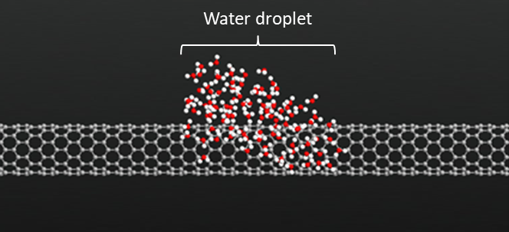
Fig. 1. Snap shot of a water-droplet-absorbed CNT in molecular dynamics simulation
- D. Sung, et al., Appl, Phys. Lett. 89, 243110 (2006).
- D. Iwasaki, Y. Suzuki and K. Watanabe, Appl. Phys. Exp. 10., 045101 (2017).

