Benchmark of density functional theory for superconductors

in elemental materials

Mitsuaki Kawamura,^{1,*} Taisuke Ozaki¹

¹Institute for Solid State Physics, The University of Tokyo, Kashiwa, Japan

* E-mail: mkawamura@isp.u-tokyo.ac.jp

The first-principle calculation of the superconducting properties such as the transition temperature and the gap function is of great interest to explore new materials as well as to understand the mechanism of known superconductor. Density functional theory for superconductors (SCDFT) [1] is one of the framework for such calculations; this method enables us to perform fully non-empirical simulation in the superconducting phase within reasonable computational cost. In this method, we can treat the electron-phonon interaction, the electron-electron repulsion, and the spin-fluctuation mediated interaction [2] in the first-principles manner. However, the accuracy of the current approximated functional of SCDFT and the effects of the spin-orbit interaction (SOI), spin-fluctuation, and the phononic anharmonicity has not been verified systematically although such a verification is highly desirable before we apply this method to the wide range of materials. Such a benchmark is also useful to find the guideline for improving the superconducting density functional. For this purpose, we started the benchmark calculation of SCDFT with our newly developed first-principles program package Superconducting-Toolkit (SCTK) [3]. In this presentation, we show benchmark results of superconducting properties calculated by SCDFT for 32 elemental materials together with computational details, and discuss accuracy of predicted transition temperature T_{C} and the effect of the spin-orbit interaction up on T_{C} (see Fig. 1).

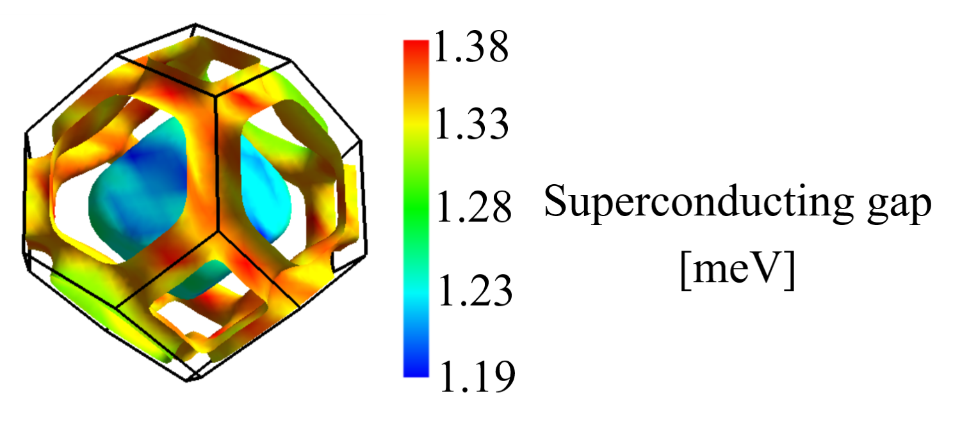
Figure 1: (color online) Superconducting gap of Pb computed by taking account of the spin-orbit interaction. If we ignore this interaction, the maximum- and the minimum- value of the gap function are reduced to 0.89 meV and 0.63 meV, respectively.

- M. Lüders, et al., Phys. Rev. B 72, 024545 (2005).
- F. Essenberger, et al., Phys. Rev. B 90, 214504 (2014).
- M. Kawamura, R. Akashi, and S. Tsuneyuki., Phys. Rev. B 95, 054506 (2017). http://sctk.osdn.jp/index.html

